  
  
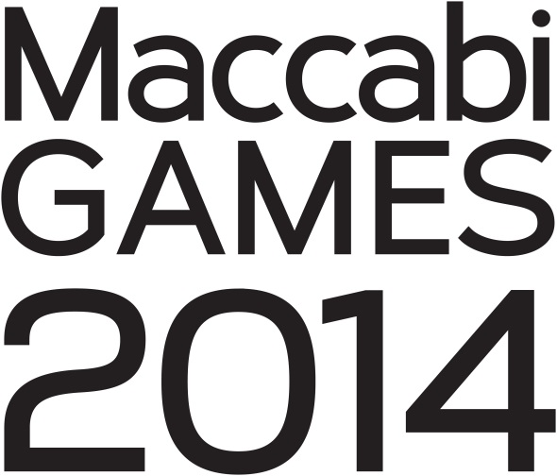  
  
**Tuesday, June 10   
Fun. Friendship. Memories.  
*More information is at* WiseSchool.tumblr.com**

**Shirts, headbands and socks MUST be preordered by May 22 at 3 p.m. mycart.wisela.org/wise-school/**